6. What is the pinout for the RS485 in the EDB series?

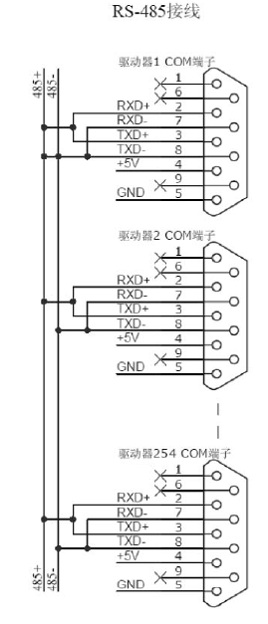

מ.י. טכנולוגיות www.my-tech.co.il F: 972-9-7656684 T: 972-9-7676678

