7. How can I change the Baud Rate of the communication at both series of drives, and
what Baud Rate is available?

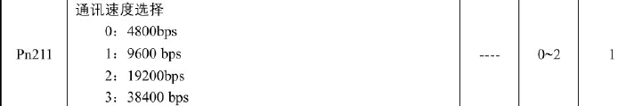

מ.י. טכנולוגיות www.my-tech.co.il F: 972-9-7656684 T: 972-9-7676678

